***SMART SOCKET***

Using Internet of Things (IoT)

|  |  |  |  |  |
| --- | --- | --- | --- | --- |
| |  | | --- | | **K. Mounika1, M. Raasi2, B. Lakshmi Keerthi3,**  **S. Kushal4** |   UG Scholars, Department of Computer Science and Engineering1234 |  | |  | | --- | | **B. S. Vara Prasad5** |   Associate Professor, Department of Computer Science and Engineering5 |

# Abstract

**Energy saving has been one of the key issues in our everyday life. In fact, energy control for some appliances is an effective method to save energy at home, since it prevents users from consuming too much energy, which is based on Internet of Things to minimize energy consumption of home appliances without deploying sensors. In our day to day life, we are using many gadgets which consume a lot of power.**

**In our smart socket we are overcoming those disadvantages by developing a portable socket prototype which can be controlled by mobile app, google assistance and accessed through cloud. Through this smart socket kit, we can control power supply even though we are not at the place where our socket is fixed. It is a 2-way socket i.e., We can access this socket through cloud as well as manually. We are developing an app where we can control each and every device according to their configured module and can be controlled individually. The main goal of our project is to reduce the wastage of power supply. It can accept up to 230v, 50hz so we can connect any appliance to our socket.**

**Keywords - Internet Of Things, Socket, MIT app inventor, Google Assistance, IFTTT.**

INTRODUCTION

Internet of Things is a concept where each device is assigned to an IP address and through that IP address anyone makes that device identifiable on internet. Basically, it started as the “Internet of Computers.” Research studies have forecast an explosive growth in the number of “things” or devices that will be connected to the Internet. The recent developments in technology which enable the utilization of Bluetooth and Wi-Fi have enabled different devices to possess capabilities of connecting with one another. The Wi-Fi shield needs connection to the internet from a wireless router or wireless hotspot and this would act as the gateway for the NodeMCU to communicate with the internet.

Internet of Things (IoT) is one of the emerging technologies at the moment. With IoT, one can control electronic system remotely. In the IoT system, many variations of data are read, collected, and transmitted in an efficient and secure manner. One of the proper modules to be used as the basis of an IoT device is the ESP- 12E due to its economical price, low power consumption capability and integrated with TCP/ IP. The device is equipped with Wi-Fi capability with satisfactory function. With the Wi-Fi feature, the ESP8266 module can connect to the internet.

PROPOSED SYSTEM

The conceptual design of the proposed smart socket for real-time remote power monitoring and controlling of connected load. As shown in the figure, the socket can be remotely accessed through a wireless medium. The instrument determines and processes the single-phase powerline voltage and current of the connected device. The socket sends the captured data to the master node when connected to a master node or controller. The socket utilizes wireless connectivity and a memory for storing raw data. Special signal-conditioning circuits are also used to sample the line voltage and current and relay data. Furthermore, the socket can turn on or off the connected appliance from the master controller.

1. *IoT (Internet of Things)*

The Internet of Things (IoT) can be described as an everyday commodity for mobile phones, Internet televisions, sensors and Internet actuators, where devices are intelligently connected and allow for new communication between people and the public. The number of elves and devices connected to the Internet will increase from 100.4 million in 2011 to 2.1 billion by 2021, an increase of 36% per year. In 2011, 80G machine-to-machine (M2M) connections were made via mobile networks such as 2G and 3G, and the cost of M2M on mobile networks is generally low and this ratio is expected to increase to 93% by 2021. . Fixed networks as illustrated in Figure 1. Now, anyone, anytime, anywhere, has connectivity and it is hoped that these connections will be able to extend and create a fully sophisticated dynamic IoT network. The Internet of Things revolutionizes many sectors, from automation, transportation, energy, healthcare, financial services to nanotechnology. IoT technology can also be used to create a new concept and wider development space for smart homes to improve intelligence, comfort and quality of life. Various devices and home accessories, lighting, air conditioning, home security and entertainment systems that can be remotely controlled from smartphones or tablets are now connected to the Internet. In addition to controlling the equipment, the home environment can be continuously monitored to maintain the desired temperature or to monitor energy usage. Therefore, it contributes to overall cost reduction and energy savings, which is one of the main concerns of today.

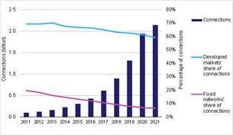

Fig.1:M2M device connections and future predictions

This document is an extension of our previous work and provides a flexible and low-base home monitoring and control system with integrated micro-web server with IP connectivity to remotely access and control devices and devices via the phone application Smart based on Android. Our proposed solution does not require a dedicated server PC for similar kind systems and provides a new communication protocol for monitoring and device communication, rather than changing functionality. We use RESTful based web services as an interoperable application layer that can be integrated directly.

1. *NODEMCU*

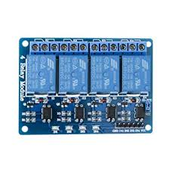The ESP Wi-Fi modules are microcontrollers with Wi-Fi and Bluetooth (not all models) capability, developed by Espressif Systems It consists of many development boards like ESP8266-01, ESP8266, NodeMCU, ESP12, ESP32 etc. All the development boards can be easily programmed using Arduino IDE and can be used in a variety of applications. Home Automation Internet of things (ioT), Smart devices etc. You can also check out the Arduino ESP8266 projects if you have to interface an ESP with Arduino board large collection of ESP8266 projects with circuit diagram, code and hardware demonstration. Ever since I started to work with the ESP Wi-Fi Modules, I always wanted to build a smart Wi-Fi socket that enables me to control my AC loads wirelessly through smart phone. While products like these are already available in the market, like the popular Moko Wi-Fi Smart Plug or Sonoff, they are a bit expensive and on top of that it doesn't give you the joy of building your own.

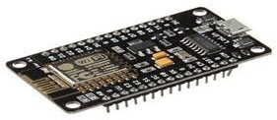

Fig.2:NODEMCU

1. 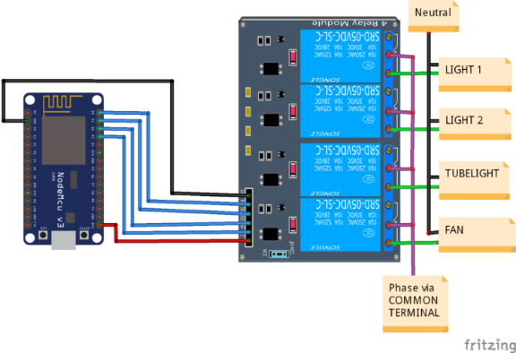Block Diagram

Fig.3:Block Diagram

1. Relay

The main usage of the **Relay** was seen in the history for transmitting and receiving the information, that was called as Morse code where the input signals used to be either 1 or 0, these change in signals were mechanically noted in terms of ON and OFF of a light bulb or a beep sound, it means those pulses of 1s and 0s are converted as mechanical ON and OFF using electromagnets. Later this was improvised and used in various applications. Let’s see how this electromagnet acts as a switch and why it is named as RELAY.

Fig.4:Relay

*SYSTEM DESIGN AND IMPLEMENTATION*

Modules Description

System analysis uses various sorts of information systems to support many processors needed to hold out their business function. Each of those information systems features a particular purpose, and every have a lifetime of its own. This “life of its own “concept is named the System Development Life Cycle.

Software Requirements

Database : Mad Blocks dashboard

IDE : Arduino

Coding Language : java

Hardware Requirements

Micro Controller : NodeMCU

Regulated Power Supply : 230AC-5V

Phone : Android mobile

**Hardware Requirements**

Micro Controller : NodeMCU

Regulated Power Supply : 230AC-5V

Phone : Android mobile

Wi-Fi (Wireless Fidelity) could also be a wireless networking technology used for exchanging the knowledge between 2 or tons of de-vices while not mistreatment cables or wires.There area unit numerous Wi-Fi technologies like Wi-Fi 802.11a, 802.11b, 802.11g and 802.11n. Here, during this project Wi-Fi module issued to receive commands from internet and activate hundreds through TRIAC Optocoupler by execution a program written at intervals the Wi-Fi module. Hence, no microcontroller is used during this project to drive hundreds.

Manual

The existing smart socket focusing only on remotely switching ON and OFF and energy monitoring. smart socket isn't extremely smart still it requires control signal from human to work. it'll define a way during which we implement a Home automation using smart socket to regulate and monitor the varied appliances. This device can directly get connected to existing home controller and switch bent be a part of the system.

Application

App Inventor may be a free, cloud-based service that permits you to form your own mobile apps employing a blocks-based programing language. You access App Inventor employing a browser (Chrome, Firefox, Safari). With these beginner-friendly tutorials, you'll learn the fundamentals of programming apps for Android devices. Here we are getting to use MIT app inventor.

Google Assistance

We used google assistance from the IFTTT web-based service which allows users to attach between web services in order that , when something happens with one service, a trigger pops and an action takes place automatically on the opposite . IFTTT is an acronym of “If This Then That”.

RELATED WORKS:

1. The existing system for controlling home
2. • Lot of energy wastage.
3. • Time consumption.
4. • Lot of wastage in electricity.
5. • It is outdated now.
6. • Makes use of arduino and GSM.

* The existing system for controlling home appliances is either a manual or remote-control process.
* Manually, home appliances like Light, fan, etc. are controlled by citizens.
* Lot of energy wastage.
* Time consumption.
* Lot of wastage in electricity.
* It'soutdated now.
* Makes use of NodeMCU.

Disadvantages of Existing System

* The existing infra-red (IR) or Blue-tooth remote controls present within the market are generally appliance specific and therefore the same can't be used interchangeably.
* Electrical appliances connected through Bluetooth making use of Blue-tooth enabled smart phones can't be managed from a foreign location.
* Thus, functions like having the ability to show on an air-conditioner while returning home can't be through with such systems.

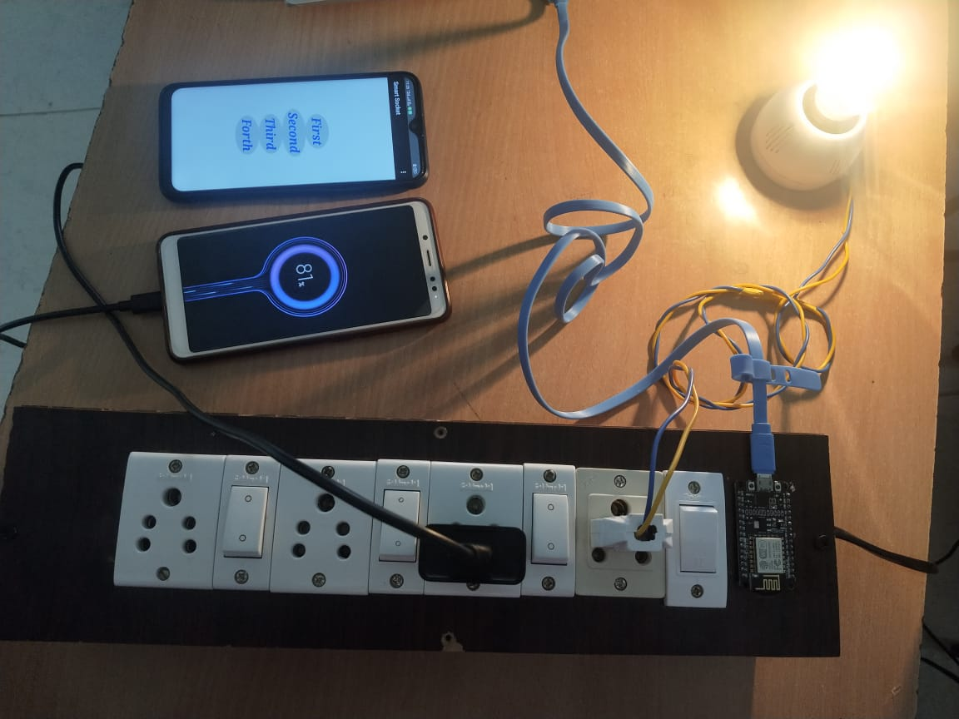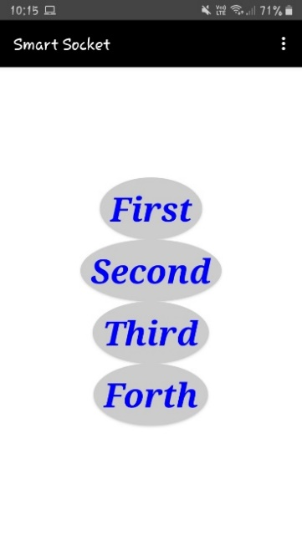RESULT AND ANALYSIS

fig4: MIT App

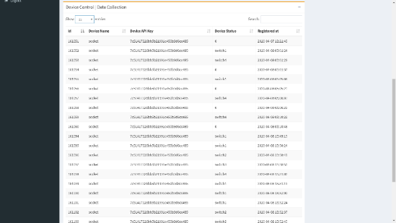

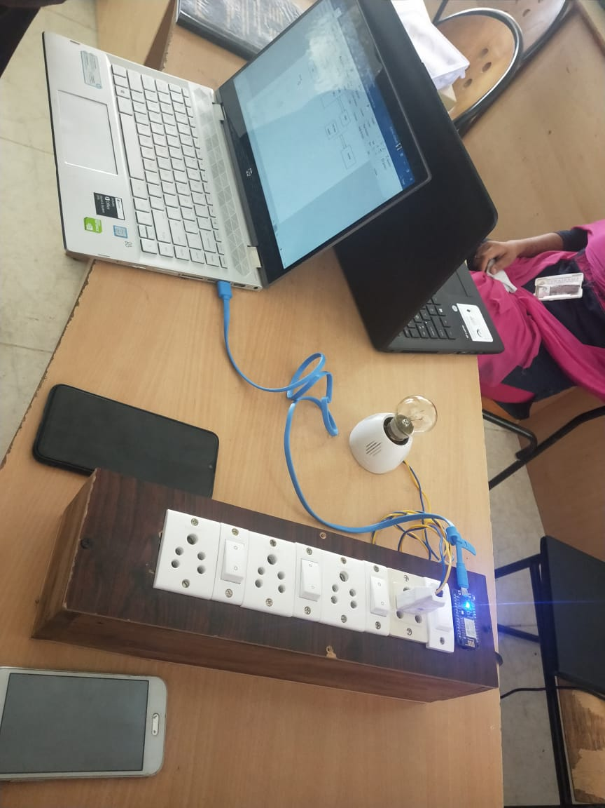fig5:Database

Fig6: All connections

Fig7: Complete Kit

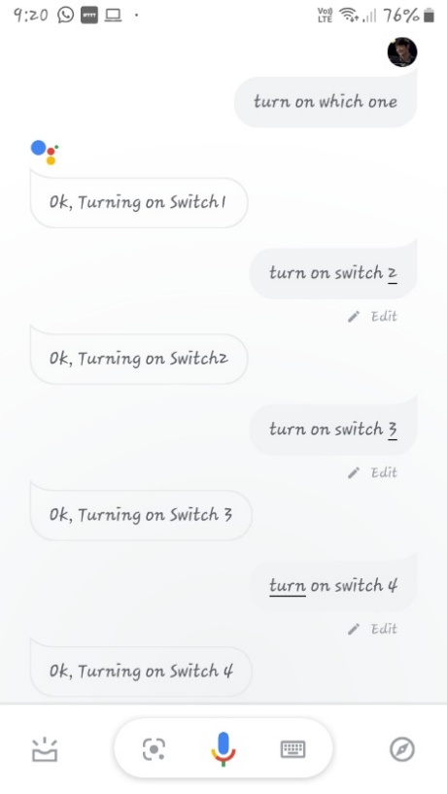

Fig8:Google Assistance(on)

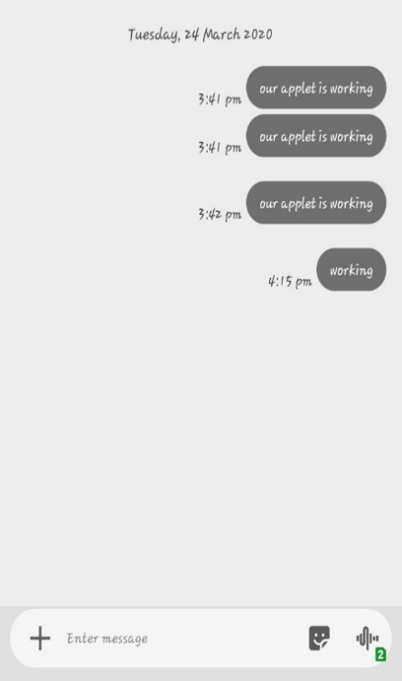 Fig9: Android SMS

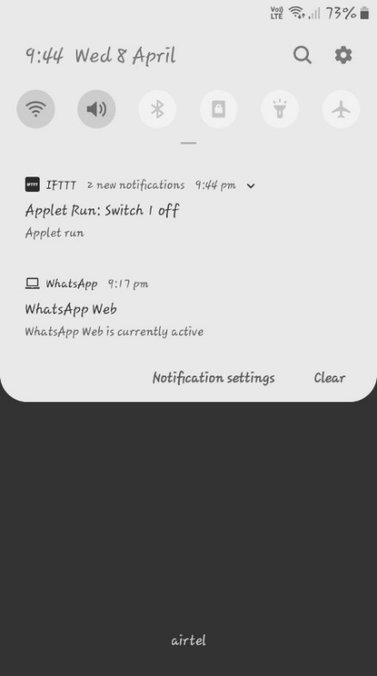 Fig 10: Mail

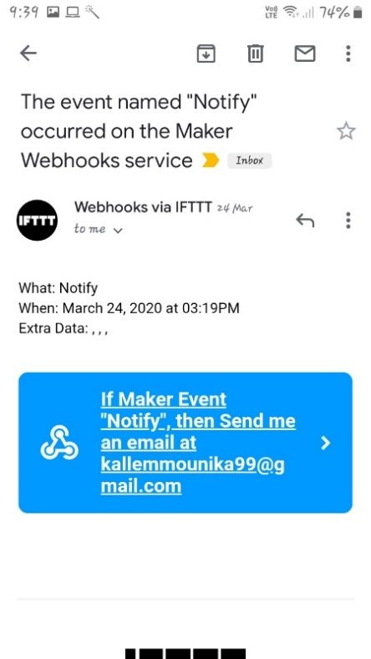

Fig 12: Notification

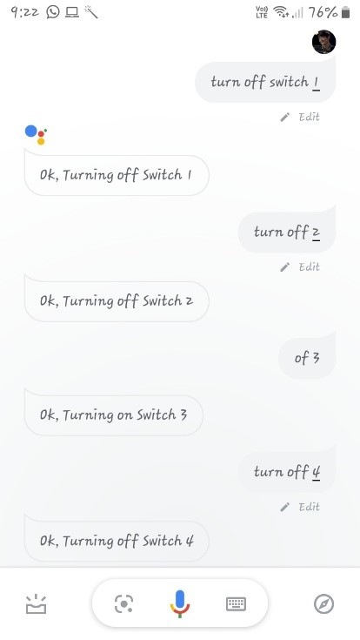

Fig11:Google Assistance (off)

CONCLUSION:

It is evident from this project work that a private contol home automation system is often cheaply made up of low-cost locally available components and may be wont to control multifarious home appliances starting from the safety lamps, the tv to the air con system and even the whole house lighting system. And better still, the components required are so small and few that they will be packaged into a little inconspicuous container. The designed home automation system was tested variety of times and authorized to regulate different home appliances utilized in the lighting system, air con system, home entertainment system and lots of more. Hence, this technique is scalable and versatile.  
The future work includes:

1. To form it available in very less cost to ruler area peoples and schools.
2. Reducing more complexity of things and simply available to people.

**REFERENCES**

[1] Adam Zippere, A. Aloise-Young, Siddharth Suryanarayanan, Robin Roche, Lieko Earle, Dane Christensen, Pablo Bauleo, Daniel Zimmerle, “Electric Energy Management within the Smart Home: Perspectives on Enabling Technologies and Consumer Behavior”,IEEE.

[2] Poojashri S, Lakshmi R, Shruthi K M, Usha K R,Vijayalaxmi R Patil, “Residence Energy System using IoT”, International Journal for Research project & Development| Vol. 5, Issue 04, 2017.

[3] Miss.Chetashri Prakash Purandare, Prof D. D. Patil, “SMART SUPPORTED WIRELESS AND IoT”, IJARIIE, Vol-3 Issue-2 2017.

[4] Jiang Feng Dai Jian Wu Fe ZouYan,“Design of Socket supported Intelligent Control and Energy Management”, International Journal of Advanced Computing and Applications, Vol. 6, No. 10, 2015.

[5] Mr.Sagar s karakalmani ,“Residency energy control system (RECOs) using wireless socket and IOT “,International Journal of Advanced Research in Electronics and Communication Engineering (IJARECE) Volume 6, Issue 5, May 2017.

[6] V.Kandasamy, SindhupriyaParanthaman, “PIC 16F877A based Hostel Automation using Residence Energy Control System (RECOS) Design”, International Journal for Scientific Research project & Development| Vol. 5, Issue 01, 2017.

[7] M. Lee, Y. Uhm, Y. Kim, G. Kim, and S. Park, ``Intelligent power management device with middleware-based living pattern learning for power reduction,'' IEEE Trans. Consum. Electron., vol. 55, no. 4, pp. 2081_2089, Nov. 2009.

[8] W. K. Park, C. S. Choi, I. W. Lee, and J. Jang, “Energy ef_cient multifunction home gateway in always-on home environment,'' IEEE Trans.Consum. Electron., vol. 56, no. 1, pp. 106_111, Mar. 2010.

[9] Standby Power Annex: Summary of Activities and Outcomes Final Report, MAIA Consulting, Geneva, Switzerland, Apr. 2014.

[10] A. H. Mohsenian-Rad, V. W. Wong, J. Jatskevich, R. Schober, and A. Leon-Garcia, ``Autonomous demand-side management supported gametheoreticenergy consumption scheduling for the longer term smart grid,'' IEEETrans. Smart Grid, vol. 1, no. 3, pp. 320_331, Dec. 2010.

[11] <https://www.irjet.net/archives/V4/i1/IRJET-V4I1302.pdf>

[12]http://ieeexplore.ieee.org/document/7955836/

[13] Atzori, Luigi, Antonio Iera, and Giacomo Morabito. "The internet of things: A survey." Computer networks 54.15 (2010): 2787-2805.

[14] Al-Ali, Abdul-Rahman, and Mohammad Al-Rousan. "Java-based home automation system."Consumer Electronics, IEEE Transactions on 50.2 (2004): 498-504.